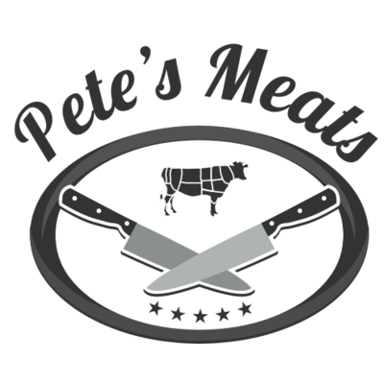
Catering Menu
 | 1/2  Tray | Full  Tray |  |  |  | 1/2  Tray |  | Full  Tray
Shrimp Skewers | $65.00 | $125.00 |  | Chicken Wings | $55.00 |  | $105.00
Beef Skewers | $60.00 | $115.00 |  | House Smoked Ribs | $65.00 |  | $125.00
Chicken Skewers | $45.00 | $85.00 |  | House Smoked Pulled Pork | $59.00 |  | $110.00
Baby Lamb Chops | $130.00 | $250.00 |  | Sliced Skirt Steak & Chimi | $120.00 |  | $225.00
Mini Cheeseburger Sliders | $65.00 | $120.00 |  | Sliced Prime Rib | $129.00 |  | $229.00
Pulled Pork Sliders | $69.00 | $130.00 |  | Sliced Filet Mignon | $179.00 |  | $280.00
Mini Crab Cakes | $75.00 | $140.00 |  | Sausage & Peppers | $49.00 |  | $80.00
Cole Slaw | $25.00 | $45.00 |  | Grilled Chicken Cutlets | $44.00 |  | $75.00
Potato Salad | $25.00 | $45.00 |  | Breaded Chicken Cutlets | $44.00 |  | $75.00
Macaroni Salad | $25.00 | $45.00 |  | Macaroni & Cheese | $40.00 |  | $80.00
Mozzarella Caprese Salad | $40.00 | $75.00 |  | Short Rib Mac & Cheese | $55.00 |  | $100.00
Garden Salad | $20.00 | $35.00 |  | Gourmet Hot Dogs & Rolls | $49.00 |  | $85.00
Caesar Salad | $25.00 | $45.00 |  | Pete's Burgers | $49.00 |  | $85.00
House made Chips | $15.00 | $30.00 |  | Crab Cakes | $75.00 |  | $140.00
Grilled Veggies | $25.00 | $45.00 |  | Lobster Rolls | $99.00 |  | $189.00
Guacamole & Chips | $30.00 | $55.00 |  | Grilled 1/2 Chickens | $50.00 |  | $95.00
Roasted Potato | $20.00 | $35.00 |  | Grilled Salmon | $60.00 |  | $110.00
Jasmine Rice | $25.00 | $45.00 |  | Grilled Shrimp | $75.00 |  | $145.00
Skin on Fries | $25.00 | $45.00 |  | Chicken Tenders | $40.00 |  | $75.00
Sweet Potato Fries | $30.00 | $55.00
Corn on Cobb | $25.00 | $50.00 |  | Boneless Short Rib | $89.00 |  | $179.00
Pastrami Sliders | $75.00 | $140.00 |  | Penne Vodka | $45.00 |  | $85.00
Butcher’s Meatballs | $39.00 | $65.00 |  | Lasagna | $50.00 |  | $95.00
Cold Cut Sandwich Platter | ---- | $44.99 |  | Mozzarella Sticks | $49.00 |  | $89.00
1/2 tray feeds 7-10 people. Full tray feeds 10-15 people.
Chafing Dish Buffet Sets Available (water pans, racks, fuel, & serving utensils) $9 + $6 deposit refunded when retuning racks & water pans
Call to place your order today!

